 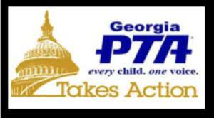

PTSA Legislative Report January 2022

National PTA’s Public Policy Priorities for the 117th congress:

* Promoting safe, supportive and inclusive practices in school for all students.
* Increasing Federal Investment in Public Education.
* Reauthorization of the child Nutrition Act.
* Support Sensible solutions to Gun Violence.

Respectfully Submitted,

Rukhama Sayed

PRHS PTSA Legislative Liaison 3 PRHS PTSA Legislative Report