**Gwinnett County COVID-19 Community Resource Guide**

**Food Security** **2**

Food Banks by City 2

Atlanta Food Pantries 5

Finding Meals for School-aged Children 6

Food4Life Grocery Request and Delivery 9

**Utilities and Resources** **9**

Utilities 9

Housing & Rent 10

Filing for Unemployment 12

Small Businesses 13

Resources for College Students 13

**Immigration Resources** **14**

Resources for Undocumented People 14

Non-Profit Legal Organizations Located in Gwinnett 14

Non-Profit Legal Organizations in Fulton County / Atlanta 14

Non-Profit Legal Organizations in Dekalb County 15

Other Legal Non-Profits in the State of Georgia 15

ICE Raids 16

Unemployment Benefits and DACA 16

**Education Resources** **17**

Free Access to Books 17

PBS Resources 17

Online Resources & Websites for Supplemental Learning 19

**Public Health Information** **21**

Coronavirus & COVID-19 Information and Facts 21

Low-cost Clinics With Sliding Scales 22

Telemedicine 23

Testing Sites 23

Domestic Violence Resources 23

Anti-Asian Racist Incidents 23

Fitness and Physical Health 24

# 

# 

# 

# **Food Security**

## 

## **Food Banks by City**

Please call before going to any of these pantries or kitchens to make sure they are open and serving people. If you do not see your city listed, please look at neighboring cities.

* Buford
  + Buford Family SDA Church, 4042 Friendship Road, Buford, GA 30518, 678-292-5954
  + North Gwinnett Co-op, 4395 Commerce Dr., Buford, GA 30518, 770-271-9733
  + The Bridge Community COG, 2026 Braselton Hwy, Buford, GA 30519, 470-299-8300
  + Exodus Outreach, Inc., 251 Bona Rd., Buford, Georgia 30518, 770-945-9064
* Dacula
  + Hamilton Mill United Methodist, 1450 Pine Road, Dacula, GA 30019, 770-271-8855
* Doraville
  + Center for Pan-Asian Community Services, 3510 Shallowford Road NE, Atlanta, GA 30341, (770) 936-0969 ***in-language services possible
* Duluth
  + Life Changers Family Worship Christian Center, 3256 Buford Highway, Duluth, GA 30096, 678-540-4800
  + Duluth Cooperative Ministry, Inc., 3395 Fox St NW., Duluth, GA 30096, 770-232-7454
  + Friendship Baptist Church of Duluth Inc., 3375 Church Lane, Duluth, GA 30096, 770-497-8227
  + CrossPointe the Church at Gwinnett Ctr, 1800 Satellite Blvd., Duluth, GA 30097, 678-812-4500
* Grayson
  + Highlands Associated Reformed Presbyterian Church, 830 Grayson Parkway, Grayson, GA 30017, 770-978-3001
  + Southeast Gwinnett Co-op, 55 Grayson Industrial Parkway, Grayson, GA 30017, 770-985-5229
* Johns Creek
  + Good News Atlanta Church, 11000 Rogers Circle, Johns Creek, GA 30097, 678 473 1594
* Lawrenceville
  + Joy Community Kitchen, Inc., 329 Grayson Highway, Lawrenceville, GA 30046, 770-963-4858
  + Love Outreach Mission, 1294 Braselton Highway, Lawrenceville, GA 30043, 770-339-1916
  + The Quinn House, 555 Hurricane Shoals Road NW, Lawrenceville, GA 30046, 770-962-0470
  + Streetwise Georgia, Inc., 1777 Cedars Road, Lawrenceville, GA 30045, 678-985-9952
  + Gethsemane Haitian Church of God, 260 Shannon Way, Lawrenceville, GA 30044, 770-558-1950
  + Ministerio Shalom Inc., 3865 Lawrenceville Highway, Lawrenceville, GA 30044, 770-674-4352
  + New Life Fellowship, Inc. - Bread of Life Food Ministries, 990 Martins Chapel Rd., Lawrenceville, GA 30045, 770-513-1007
  + Gwinnett County Service Branch of Salvation Army, 3455 Sugarloaf Pkwy., Lawrenceville, Georgia 30044, 770-724-1661
  + Signs & Wonders, Inc., 120 S. Perry St., Lawrenceville, GA 30046, 770-962-0470
  + Vision Academy Life Center, 458 Chestnut St., Lawrenceville, GA 30045, 678-206-0688
  + Cafe Community Center, Buford Drive, Lawrenceville, GA, 770-236-8604
* Lilburn
  + Salem Missionary Baptist Church, 4700 Church Street NW, Lilburn, GA 30047, 770-923-3936
  + New Bethel International COG, 1025 Killian Hill Rd SW, Lilburn, GA 30047, 678-639-1500
  + Peace House Inc., 2158 McDaniels Bridge Ct. SW, Lilburn, GA 30047, 404-641-9248
  + Lilburn Cooperative Ministry, 5329 Five Forks Trickum, Lilburn, GA 30047, 770-931-833
  + Mercy Seed Resource Center Inc, 4037 Darling Court SW, Lilburn, GA 30047, 770-925-8600
* Loganville
  + Closest ones are in Grayson and Snellville
* Norcross
  + Big Step International Support Inc., 6051 Oakbrook Parkway, Norcross, GA 30093, 770-687-2456
  + Norcross Cooperative Ministry, 2275 Mitchell Road, Norcross, GA 30071, 770-263-8268
  + City of Hope Community Development, 182 Hunter Street, Norcross, GA 30071, 770-441-2948
  + Circle of Love - First Senior Center, 7116 Peachtree Industrial Blvd. Bldg Y, Norcross, GA 30071, 470-289-2222
* Peachtree Corners
  + Ministerio Internacional El Rey Jesus Georgia Inc., 4350 Peachtree Industrial Blvd. Ste. 500D, Peachtree Corner, GA 30071, 770-864-1023
* Snellville
  + Christ First Community Church, 4576 Lenora Church Road, Snellville, 30039, 770-885-7140
  + Overcomers House, Inc., 2114 Fountain Square, Snellville, GA 30078, 678-615-7714
  + Purpose World Inc, 1905 Highpoint RD, Snellville, GA 30078, 762-333-2630
  + Developmental Disabilities Ministries, Inc., 6320 Amherst Court, Norcross, GA 30092, 770-623-4899
* Stone Mountain
  + Potter's House Family and Children Treatment Cntr, 2300 W Park Place Blvd, Stone Mountain, GA 30087, 678-330-1400
  + Stone Mountain SDA Church, 1350 Silver Hill Road, Stone Mountain, GA 30087, 770-469-0111
  + Stone Mountain Ecumenical Co-Op Ministries, 5324 W. Mountain Street, Stone Mountain, GA 30083, 770-879-8860
  + Place of Enlightenment, Inc., 2720 Centerville Hwy., Snellville, Georgia 30078, 770- 982-8221
* Suwanee
  + Casa Vida, Inc., 2020 Lawrenceville-Suwanee Rd, Suwanee, GA 30024, 678-407-2000
* Tucker
  + NETworks Cooperative Ministry-Food Co Op, 2380 4th St, Tucker, GA 30084, (770) 939-6454

***There is also a food pantry in Marietta that provides groceries and hot meals***

Ministries United for Service and Training Soup Kitchen (Marietta)

55 Elizabeth Church Rd, Marietta, GA 30068

(770) 427-9862

## 

## **Atlanta Food Pantries**

In the event that you cannot find food pantries / kitchens that are operating in your area, below is a table from the Atlanta Community Food Bank that lists out all of the food bank partner agencies in Fulton County. You must show a valid photo ID if participating.

## 

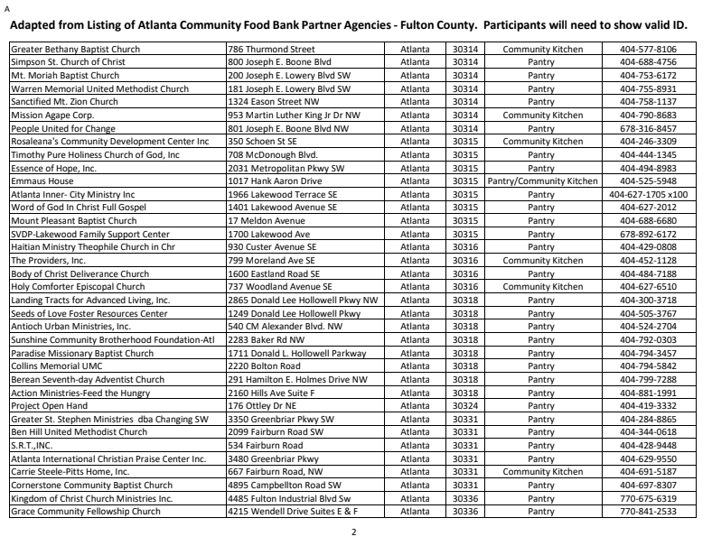

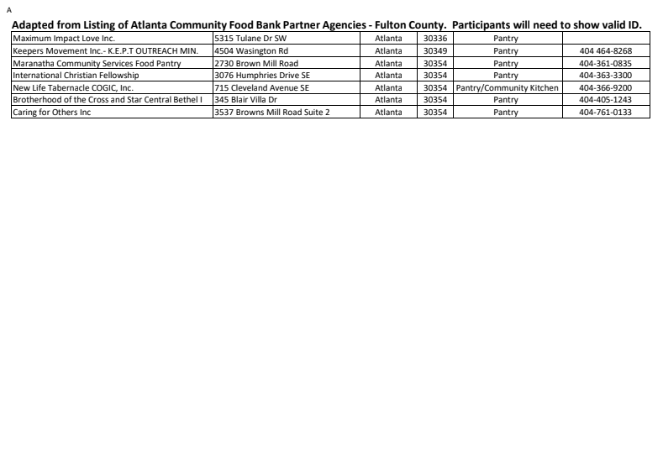

## **Finding Meals for School-aged Children**

*From Gwinnett County Public Schools:*

As part of this week’s Digital Learning Days, 68 schools (listed below) will provide lunch for pick up for anyone 18 years of age or younger between the hours of 11 a.m. and 1 p.m. These lunches will be provided at no cost to the individual through the federal School Nutrition Program. The student or child must be present to receive the meal. A child does not have to be a student at the school site to receive a meal. Again, select schools will have student lunches available for pick up between 11 a.m. and 1 p.m. every day during the weeks of March 16-20 and March 23-27.

In addition, school buses will deliver meals at bus stops in the following clusters-- Berkmar, Central Gwinnett, Discovery, Meadowcreek, Norcross, Shiloh, and South Gwinnett-- and for the following schools-- Alcova ES, Arcado ES, Berkeley Lake ES, Chesney ES, Duluth MS, Harris ES, Jackson ES, Knight ES, Lovin ES, McKendree ES, Northbrook MS, and Sycamore ES. The buses will be making stops at their regular bus stops between 11 a.m. and noon. In order to get a meal the child will need to be at the stop when the bus arrives.

As this is an unprecedented situation, this is the first time we have attempted this type of initiative. We appreciate your patience as our dedicated staff work to coordinate this effort as efficiently and safely as possible.

List of schools providing lunch for pick up for anyone 18 years of age or younger between the hours of 11 a.m. and 1 p.m.:

|  |  |
| --- | --- |
| Alcova Elementary School  Alford Elementary  Anderson-Livsey Elementary School  Annistown Elementary School  Arcado Elementary School  Baggett Elementary School  Baldwin Elementary  Beaver Ridge Elementary School  Benefield Elementary School  Berkeley Lake Elementary School  Berkmar High School  Berkmar Middle School  Bethesda Elementary School  Britt Elementary School  Cedar Hill Elementary School  Centerville Elementary School  Central Gwinnett High School  Chesney Elementary School  Corley Elementary School  Discovery High School  Duluth High School  Duluth Middle School  Ferguson Elementary School  Grace Snell Middle School  Graves Elementary School  Gwinnett InterVention Education (GIVE) Center East  Gwinnett Intervention Education (GIVE) Center West  Harris Elementary School  Hopkins Elementary School  Jackson Elementary School  Jenkins Elementary School  Jordan Middle School  Kanoheda Elementary School | Knight Elementary School  Lawrenceville Elementary School  Lilburn Elementary School  Lilburn Middle School  Lovin Elementary School  Magill Elementary School  McKendree Elementary School  Meadowcreek Elementary School  Meadowcreek High School  Minor Elementary School  Moore Middle School  Nesbit Elementary School  Norcross Elementary School  Norcross High School  Northbrook Middle School  Norton Elementary School  Partee Elementary School  Paul Duke STEM High School  Peachtree Elementary School  Pinckneyville Middle School  Radloff Middle School  Richards Middle School  Rockbridge Elementary School  Rosebud Elementary School  Shiloh Elementary School  Shiloh High School  Shiloh Middle School  Simonton Elementary School  Snellville Middle School  South Gwinnett High School  Stripling Elementary School  Summerour Middle School  Sweetwater Middle School  Sycamore Elementary School  Winn Holt Elementary School |

**Grocery Store Information**

* City Farmers Markets - All six locations are open their regular hours and all stores will be performing non-invasive temperature checks at the door to ensure the safety of everyone. Those with temperatures above 100.4 Fahrenheit will not be permitted to enter.
  + Chamblee
    - 5000 Buford Hwy, Chamblee, GA 30341, (770) 936-8858
  + Atlanta
    - 3317 Buford Hwy, Atlanta, GA 30329, (404) 458-4767
  + Snellville
    - 4002 Hwy 78, Snellville, GA 30039, (770) 972-5888
  + Marietta
    - 1167 Powder Springs St, Marietta, GA 30064, (770) 694-1000
  + Duluth
    - 1630 Pleasant Hill Rd Duluth, GA 30096, (770) 921-7373
  + Norcross
    - 5495 Jimmy Carter Blvd, Norcross, GA 30093, (770) 582-6800
* Kroger - 7:00am to 9:00pm
  + Mon-Thursday (7:00am-8:00am) - Reserved for seniors to shop
* Publix - 8:00am to 8:00pm
  + Store opens an hour early on Tuesday & Wednesday (7:00am-8:00am) - Reserved for seniors to shop
* Aldi - 9:00am to 7:00pm
* Trader Joe’s - 9:00am-7:00pm
* Walmart - 7:00am-8:30pm
  + 3/24 - 4/28: TUESDAYS ONLY - 7:00am to 8:00am reserved for seniors to shop
* Whole Foods - 8:00am to 8:00pm
  + Stores will open one hour earlier (7:00am-8:00am) so that seniors can shop before opening up the store to the general public.
* Target - 8:00am to 9:00pm
  + WEDNESDAYS 7:00am to 8:00am reserved for seniors to shop

## **Food4Life Grocery Request and Delivery**

Folks who are in need of free groceries can request them from the Atlanta Survival Program through this form:<https://airtable.com/shrBg3BzmxqI4yvyp?prefill_Food%20Restrictions%3F=No,%20anything%20is%20fine>

Delivery is not guaranteed, especially in Metro-Atlanta, but it could be worth trying to work it out with the organizers.

# **Utilities and Resources**

## **Utilities**

* Water service disconnection orders are halted for the 60 days in Atlanta, GA as of March 13. 2020. (ATLANTA, GA)
* Georgia Power is suspending residential disconnections for the next 30 days beginning on March 13. (GEORGIA)
* Jackson EMC is suspending disconnection for nonpayment from March 16 through March 27. (METRO ATLANTA, GA)
* Internet:
  + Comcast, two months free internet
    - Families without Internet access can now have Comcast Essentials FREE for up to 60 days. Additionally, Comcast is increasing Internet speed for existing customers. Please see the brief facts below and click the link for more information. All inquiries regarding Comcast Internet should be directed to Comcast. To receive increased Internet speeds, existing customers will not need to do anything. New speeds will be rolled out nationally over the next few days. All NEW customers will receive a free self-install kit that includes a cable modem with a Wi-Fi router. There will be no term contract or credit check and no shipping fee. <https://www.internetessentials.com/covid19>

## 

## **Housing & Rent**

***The U.S. Department of Housing and Urban Development on Wednesday authorized the Federal Housing Administration to put an immediate moratorium on foreclosures and evictions for the next two months for single-family homeowners who are unable to pay their FHA-backed mortgages.***

*Shelters in Gwinnett*

* The Salvation Army - Divisional Headquarters
  + 1000 Center Place, Norcross, GA 30093 / (770) 441-6200
* Rainbow Village, Inc.
  + 3427 Duluth Highway 120, Duluth, GA 30096 / (770) 497-1888
  + Rainbow Village is a transitional housing program where homeless families with children find refuge to recover and rebuild their lives...
* Emma Cares, Inc.
  + P.O. Box 465133, Lawrenceville, GA 30042 / (404) 647-4996
  + Senior Housing
* Family Promise of Gwinnett County
  + 3495 B Sugarloaf Parkway, Lawrenceville, GA 30044 / (678) 376-8950
  + Family Promise brings shelter, meals, and support services to families without homes.
* Quinn House
  + 516 West Crogan Street, Lawrenceville, GA 30046 / (770) 962-7782

*Shelters in Metro-Atlanta*

* Whole Way Homes
  + 1803 Preston Lake Dr, Tucker, GA 30084 / (404) 494-6334
* Family Promise of North Fulton/DeKalb
  + 1978 Mount Vernon Rd., Dunwoody, GA 30338 / (770) 609-5407
  + Family Promise of North Fulton/DeKalb is a nonprofit organization of a Network of interfaith organizations working together to end homelessness.
* Veterans Empowerment Organization Of Georgia
  + 1599 Memorial Drive SE, Atlanta, GA 30317 / (404) 889-8710
  + The mission of Veterans Empowerment Organization Of Georgia is to provide veterans housing.
* Metro Atlanta Taskforce For the Homeless
  + 477 Peachtree Street N.E., Atlanta, GA 30308 / (404) 787-5826
  + Metro Atlanta Taskforce For the Homeless Providing shelter, housing outreach, transportation, employment, and health care.
* Atlanta City Baptist Rescue Mission
  + 316 Peters St SW, Atlanta, GA 30313 / (404) 577-3409
  + Short-term shelter program. Each client is provided 21 days of temporary stay each month. Open each evening at 4:30 p.m
* Fuqua Hall Transitional Housing
  + 144 Mills Street, Atlanta, GA 30313 / (404) 350-1300
  + Fuqua Hall, located at 144 Mills Street, consists of 92 single-unit apartments for guests who volunteer, work full time, and/or attend school.
* Red Shield Services, Salvation Army
  + 400 Luckie St. N.W, Atlanta, GA 30313 / (404) 486-2701
  + The Salvation Army in Atlanta has become well known for their readiness to give emergency family and personal assistance quickly and compassion
* Salvation Army Red Shield Services Atlanta
  + 469 Marietta Street, Atlanta, GA 30313 / (404) 486-2900
* The Shepherd's Inn Downtown Atlanta Homeless Shelter
  + 165 Ivan Allen Blvd NW, Atlanta, GA 30313 / (404) 588-4015
  + Atlanta Mission is the city's largest and longest-running provider of services to homeless men, women and children.
* Nicholas House
  + 830 Boulevard SE, Atlanta, GA 30312 / (404) 622-0793
  + Emergency shelter for homeless families without income, they can accommodate about 50 individuals from 12 different families at any given time.&nbs
* Central Outreach and Advocacy Center
  + 201 Washington Street, Atlanta, GA 30303 / (404) 659-7119
* Gateway Center Atlanta
  + 275 Pryor St SW, Atlanta, GA 30303 / (404) 215-6600
* Trinity Urban Ministries of Atlanta (Trinity Table & Trinity House)
  + 265 Washington Street, Atlanta, GA 30303 / (404) 577-6651
* Atlanta Day Shelter for Women and Children Inc.
  + 655 Ethel Street Nw, Atlanta, GA 30318 / (404) 588-4007
  + Atlanta Mission is the city's largest and longest-running provider of services to homeless men, women and children.
* Atlanta Mission
  + 921 Howell Mill Road, Atlanta, GA 30318 / (404) 367-2465
* Atlanta Union Mission
  + 2353 Bolton Rd. NW, Atlanta, GA 30318 / (404) 588-4000
  + Atlanta Mission is the city's largest and longest-running provider of services to homeless men, women and children.
* Jefferson Place Emergency Shelter (Atlanta)
  + 1135 Jefferson St. NW, Atlanta, GA 30318 / (404) 613-0412
  + This is a men only homeless shelter.
* Solomon's Temple Inc.
  + 2836 Springdale Road SW, Atlanta, GA 30315 / (404) 762-4646
  + Solomon's temple foundation, inc. provides a safe, supportive environment for homeless women and children in Atlanta.
* Fragments Ministry Transitional House
  + 635 Pearce St., Atlanta, GA 30310
  + (678) 598-0651
* Jars of Clay Outreach - Kingdom Worship Center
  + 937 Sims St SW, Atlanta, GA 30310 / (404) 586-9793
  + Jars of Clay Outreach is an emergency shelter is a system of housing (usually in a shelter) to aid when a person has no safe place to sleep.
* Elizabeth Inn Emergency Shelter (Marietta)
  + 55 Elizabeth Church Road, Marietta, GA 30060 / (770) 427-9862
* The Center For Family Resources
  + 995 Roswell Street, NE, Marietta, GA 30060 / (770) 428-2601

## **Filing for Unemployment**

Unemployment Benefits: The Georgia Department of Labor is suspending in-person requirements for services provided by the agency. In accordance with Governor Kemp's recommendation, the GDOL is providing online access to unemployment services, partial claim access for employers, and other reemployment services;

* For contractors or freelancers who may not qualify for regular Unemployment Insurance, you may qualify for Disaster Unemployment Assistance through the Federal Emergency Management Agency.
  + <https://dol.georgia.gov/faqs-individuals/individuals-faqs-disaster-related-benefits>
* Information about applying for unemployment from the state of GA:
  + <https://dol.georgia.gov/get-unemployment-assistance>
* Information about applying for unemployment from the US Department of Labor: <https://www.dol.gov/general/topic/unemployment-insurance>
* Documents needed to file for unemployment:
  + <https://dol.georgia.gov/unemployment-insurance-benefits-documents>

## **Small Businesses**

* Mayor Bottoms issued an executive order to provide $7 million in emergency funding for COVID-19 crisis. The Mayor has allocated $1.5 million to support small businesses. Please reach out to the head of Invest Atlanta for more information: [eklementich@investatlanta.com](mailto:eklementich@investatlanta.com)
* Small businesses can qualify for a small loan through the Small Business Administration: <https://disasterloan.sba.gov/ela/Declarations>
  + Resource on navigating applying for small business loans: <https://williamsteusink.com/law-news-articles/business-law/disaster-loan-vs-7a-navigating-the-covid-19-sba-loan-options/>
* Facebook is offering $100 million in loans to support small businesses during this time.

## **Resources for College Students**

* Universities & colleges Decisions:
  + All Georgia public colleges will be closed for at least the next two weeks.
  + Emory University has extended spring break until March 22 and will transition to remote learning for the remainder of the semester, beginning on March 23.
  + Spelman College will transition to remote learning, beginning on March 23.
  + Agnes Scott College will transition to remote learning on March 23 until April 3.
  + Morehouse College has suspended all large public events. Spring break has been extended for one week and remote learning will begin March 23 until the end of the Spring semester.
  + Clark Atlanta University has extended spring break until March 22 and will transition to remote learning on March 23. All students in residential house must be moved out by March 21.
  + Oglethorpe University has canceled classes, beginning on Monday, March 16 and will transition to online learning on March 24. Students are encouraged to move-out of residential housing.
* Displaced Atlanta students can request temporary housing and storage through accessing the community-made Google doc: <https://docs.google.com/forms/d/e/1FAIpQLSeapd9eMmdwkHANJeVWnsm0k7rRDVknoTqzQoMwatCC4olaAg/viewform>

# **Immigration Resources**

As of March 18, U.S. Citizenship and Immigration Services has suspended routine in-person services until at least April 1 to help slow the spread of Coronavirus Disease 2019 (COVID-19). USCIS staff will continue to perform duties that do not involve contact with the public. However, USCIS will provide emergency services for limited situations. To schedule an emergency appointment contact the USCIS Contact Center. Visit CoronaVirus.gov for a complete list of CDC travel health notices. Learn about the Department of Homeland Security’s response.

## **Resources for Undocumented People**

* Georgia-specific resources for undocumented people: <https://docs.google.com/document/u/1/d/1CoLHrqoJY684SZFOS5HP5-OWHLpDd3Ty4Fj2jwwaDV8/edit>
* Google spreadsheet with multiple national and state-specific resources:
  + <https://docs.google.com/spreadsheets/u/1/d/18p9OSlLpSYanIoUC-gEbhVbRMYVUfw4wyrixa9ekGdc/htmlview?fbclid=IwAR2vhLKVFjt3kT1JdoXKzVQoiB7MRLI2OAqHg7gi1eSmX6k90-xYjbomhSU&sle=true#gid=0>
* DACA & Benefits
  + <https://dacadreamedsuccess.files.wordpress.com/2015/03/e4fc_gotdaca_nowwhat.pdf>

Call first to make sure that these offices are still open during this time. A phone consultation or an email would probably be safer in light of public health concerns surrounding the coronavirus.

## **Non-Profit Legal Organizations Located in Gwinnett**

* Access To Law, Inc.
  + [http://www.accesstolawfoundation.org](http://www.accesstolawfoundation.org/) / 770-685-1499
  + 2415 Beaver Ruin Rd Suite B, Norcross, GA 30071
* Asian Americans Advancing Justice-Atlanta
  + <https://advancingjustice-atlanta.org> / 404-585-8446
  + 5680 Oakbrook Pkwy suite 148, Norcross, GA 30093

## **Non-Profit Legal Organizations in Fulton County / Atlanta**

* Georgia Asylum and Immigration Network
  + <https://georgiaasylum.org> / 678-335-6040
* Georgia Latino Alliance for Human Rights-GLAHR
  + <http://glahr.org> / 770-457-5232
  + 7 Dunwoody Park #110, Atlanta, GA 30338
* Kids in Need of Defense-KIND
  + https://supportkind.org / 404-885-3629
* Tahirih Justice Center
  + https://www.tahirih.org/locations/atlanta/
  + 470-481-4700
* Latin American Association
  + http://www.thelaa.org / 404-638-1800
  + 2750 Buford Hwy NE, Atlanta, GA 30324

## **Non-Profit Legal Organizations in Dekalb County**

* World Relief Atlanta
  + https://worldreliefatlanta.org/immigration-services / 404-294-4352
  + 655 Village Square Dr, Stone Mountain, GA 30083
* Catholic Charities Atlanta
  + <https://catholiccharitiesatlanta.org/immigration-legal-services/> 678-222-3920
  + 2305 Parklake Dr NE building 9 suite 150, Atlanta, GA 30345
* New American Pathways
  + <http://newamericanpathways.org/u-s-citizenship-services/> 404-299-6099
  + 2300 Henderson Mill Rd, Atlanta, GA 30345
* Immigrant Hope Atlanta
  + <https://www.immigranthope.org/location/atlanta-georgia/> 404-422-5700
  + 1850 Skyland Terrace NE, Atlanta, GA 30319
* Women Watch Afrika
  + <https://womenwatchafrika.org/services/> 404-759-6419
* Tapestri Inc.
  + T visas, U visas, Women Act (VAWA) petitions
  + <https://tapestri.org/>
  + 3939 Lavista Rd # E, Tucker, GA 30084 / 404-299-2185

## **Other Legal Non-Profits in the State of Georgia**

* Clinic BIA Pro bono Appeals Project
  + <https://cliniclegal.org/programs/advocacy/bia-pro-bono>
* Lutheran Services of Georgia, Inc. 
  + <http://www.lsga.org/> / 404-875-0201
  + 230 Peachtree St #1100, Atlanta, GA 30303
* State Bar of Georgia Military Legal Assistance Program
  + 404-427-8765
  + [normanz@gabar.org](mailto:normanz@gabar.org)
* Southern Poverty Law Center-SPLC
  + [https://www.splcenter.org](https://www.splcenter.org/our-issues/immigrant-justice/southeast-immigrant-freedom-initiative-en)
* U-Lead Athens (Athens)
  + Pro-bono DACA work
  + https://www.uleadathens.org / 706-224-1411
  + 130 Hope Ave, Athens, GA 30606
* Unidos Somos United (Conyers)
  + https://www.unidossomosunited.org/classes / 678-806-5677
  + 915 Center St NE, Conyers, GA 30012

## **ICE Raids**

You can find KYR resources on Advancing Justice - Atlanta’s website : <https://advancingjustice-atlanta.org/page/47>

* Raids Hotline in GA: Georgia Latino Alliance for Human Rights / 770-457-5232
* Legal consultations for LGBTQ+ immigrants:
  + [Immigration Equality: Legal Emergency National Hotline (LGBTQ+)](https://www.immigrationequality.org/get-legal-help/#.XSiz9HdFw2w)
  + 1-212-714-2904
  + Languages: English, Spanish, French, Russian
* Helps you locate people in detention:
  + National Detention & Abuse Reporting Hotline
  + 1-385-212-4842 (Monday-Friday, 12pm-8pm PST)
  + Languages: English, French

## **Unemployment Benefits and DACA**

From National Unemployment Law Project: <https://www.nelp.org/wp-content/uploads/Immigrants-Eligibility-for-Unemployment-Compensation.pdf>



# **Education Resources**

## **Free Access to Books**

[http://bit.ly/gcps_GAReading03](https://l.facebook.com/l.php?u=https%3A%2F%2Fbit.ly%2Fgcps_GAReading03%3Ffbclid%3DIwAR0pLaBTe7-99VX97JboV3TJ9R19ogYO5rrJdrglvMWNrGfx8_X1WDYm4xE&h=AT1dpI9Wg9iANTV8_T2ww4bN5DjRiRJbyLEu35ZDMlSZG3cH1kx5Y2EJNCujfNckdSi5ovUvlDuTNZHNkZ-8-42FzQvGdkwOGh_Z1ubfT1OIlvp8oXgBDYV-SVWTLr6Pgc5VrF7WW542XpMFOBTFH10nyRQbChJ2zzZ9eohIMqtAX3CxcbEdN7qAuq6m-6EeMoW-zoot7moUHnq5gBzlwbe-VV-vi_KgdSuJpspfEY7JNJAmd-gRcVXqRZLkX4O8PuwWNyLufrhgX9mPigaXJfzKs85nVVtO1QRMYAg-PE6XRaC-naiYm0PPDpXHZy62Xu6ajFbAIo3OiPW5DMvbCM_diPhk2q2wE0pBBwB9SsCQxLaoJJ4kTRcJBW2zHOD-jjoSVbouLtJFxCTWotn7yQdiaud7Mg_wt6W9UU8zBtzmqX92PtA9PnTsVfRDrweaKlHqFswAFysF_c0R8r7i_AuVuT5TEWmLdMqfNvDA-rO4IfExUS65KFMG8gxtUM8qw1rLuHKOPa6a4Y21IoIXHOwUhRKY5zbmgOiynXRptCfbtEMK1pwkOH39eIPoW59KZlDWC46Le_bEuSzb2kV1LCOg7oLS5WzeG1CucjqdYsfMYPu-ASXAtAXKe4boE1xN)

The above website leads you to the registration page for Georgia’s statewide reading initiative, Get Georgia Reading. Families have access to more than 6,400 online books and age-appropriate news articles!

## **PBS Resources**

* PBS Learning Media: <https://gpb.pbslearningmedia.org/>
  + Parents, students, and teachers can access standards-aligned videos, interactives, and lesson plans in a variety of topics.
* PBS Kids Video App: <https://pbskids.org/apps/pbs-kids-video.html>
  + The PBS KIDS Video app gives kids and parents access to thousands of free videos, including full episodes and clips from top PBS KIDS series. Stream the PBS KIDS 24/7 channel on the app for free, no prescription required! Childsafe and there are new videos every Friday.
* PBS Kids Game App: <https://pbskids.org/apps/play-pbs-kids-games.html>
  + FREE games for kids 2-8 will be added all the time, encouraging your child to engage in skills related to science, math, creativity and more in gameplay alongside their favorite characters!
* Parents can sign up for PBS Kids Daily Newsletter to receive a newsletter each week with offers, tips, and activities to keep their children engaged while schools are closed due to coronavirus concerns.

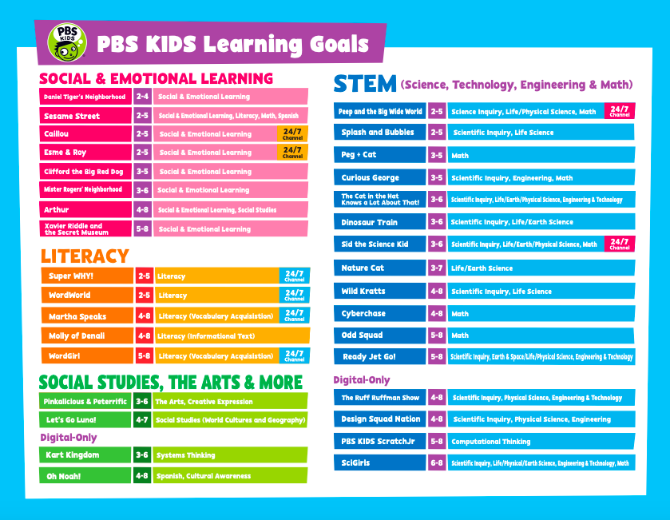

## 

## **Online Resources & Websites for Supplemental Learning**

The companies in the table below are offering free subscriptions due to school closures.

|  |  |
| --- | --- |
| **Company** | **Link** |
| Discovery Ed | <https://www.discoveryeducation.com/coronavirus-response/> |
| BrainPop | <https://educators.brainpop.com/2020/02/19/free-brainpop-access-for-schools-affected-by-the-corona-virus/?utm_source=organic&utm_medium=social&utm_campaign=coronavirus&utm_content=free-access> |
| Kahoot | <https://kahoot.com/blog/2020/02/27/kahoot-free-access-schools-higher-education-coronavirus/> |
| Pronto | <https://pronto.io/coronavirus/> |
| BookCreator App | <https://bookcreator.com/2020/03/support-for-schools-affected-by-coronavirus/> |
| Google for Edu | <https://www.blog.google/outreach-initiatives/education/distancelearning-covid19> |
| Tynker | <https://mailchi.mp/tynker/in-support-of-schools-facing-health-related-closure> |
| Buncee | <https://blog.buncee.com/supporting-remote-student-learning/> |
| Pear Deck | <https://www.peardeck.com/staying-connected> |
| Kami | <https://blog.kamiapp.com/remote-learning-with-kami-during-school-shutdowns/> |
| Parlay | <https://parlayideas.com/school-closure-support/> |
| Elementari | <https://docs.google.com/forms/d/e/1FAIpQLSdJ1LAywQdwvNKN_SpsypVA48XOaoCTQoGhuaP7e12fgwPnWA/viewform> |
| EdPuzzle | <https://support.edpuzzle.com/hc/en-us/articles/360039805612-Help-for-schools-affected-by-Covid-19> |
| Wakelet | <https://wakelet.com/wake/3af73ea4-a652-4e38-934d-765aefe0f35b> |
| Twinkl | <https://www.twinkl.com/blog/how-to-utilise-twinkl-during-the-coronavirus-shutdown-a-guide-for-schools?utm_source=twitter&utm_medium=social&utm_campaign=corona> |
| Hapara | <https://hapara.com/from-home/> |
| Manga High | <https://www.mangahigh.com/en-gb/blog/2020-03-06-free-access-schools-online-maths-coronavirus> |
| ListenWire | <http://blog.listenwise.com/2020/03/listenwise-support-for-schools-affected-by-the-coronavirus/> |
| MobyMax | <http://press.mobymax.com/mobymax-to-provide-all-k-8-schools-and-school-districts-closed-by-covid-19-with-free-internet-learning-software> |
| GoGuardian | <https://www.goguardian.com/blog/learning/goguardian-teacher-for-remote-learning/> |
| Seterra Geography | <https://online.seterra.com/en/p/corona-support> |
| We Video | <https://www.wevideo.com/education> |
| Education Perfect | <https://epforlearning.com/2020/education-perfects-technology-minimising-impact-on-100-coronavirus-affected-schools-in-china/> |
| Slido Education | <https://blog.sli.do/slido-for-education/> |
| Breakout Edu | <https://www.breakoutedu.com/funathome> |
| Microsoft Education | <https://educationblog.microsoft.com/en-us/2020/03/how-schools-can-ramp-up-remote-learning-programs-quickly-with-microsoft-teams/> |
| NearPod | <https://nearpod.com/coronavirus> |
| Zoom | <https://blog.zoom.us/wordpress/2020/02/26/zoom-commitment-user-support-business-continuity-during-coronavirus-outbreak/> |
| ScreenCastify | <https://twitter.com/Screencastify/status/1226934956930281472> |
| Mystery Science | <https://mysteryscience.com/?fbclid=IwAR0tiDhJA1fs0tvraKnXpDLa2JlJGXQhzPR4UnQRVfbOR1Ca3C5yQY5tNwQ> |
| Age of Learning (ABCMouse, Adventure Academy, ReadingIQ) | <https://www.ageoflearning.com/schools> |

# **Public Health Information**

## **Coronavirus & COVID-19 Information and Facts**

**AANHPI In-Language Resources**

[https://docs.google.com/spreadsheets/u/0/d/1XePaKv7Ar59PG7z37QqzIb8WfynEx5BK5ZfK3VLXIJA/htmlview#](https://docs.google.com/spreadsheets/u/0/d/1XePaKv7Ar59PG7z37QqzIb8WfynEx5BK5ZfK3VLXIJA/htmlview)

**Simplified Chinese Health Links**

CDC

如果您感染了 冠状病毒疾病 2019 (COVID-19) 该怎么办 (what to do if you are sick with COVID-19)

<https://www.cdc.gov/coronavirus/2019-ncov/downloads/sick-with-2019-nCoV-fact-sheet-chinese.pdf>

关于冠状病毒疾病 2019 (COVID-19) 您需要知道什么 (What you need to Know)

<https://www.cdc.gov/coronavirus/2019-ncov/downloads/2019-ncov-factsheet-chinese.pdf>

阻止病毒传播 (stop the spread of germs)

<https://www.cdc.gov/coronavirus/2019-ncov/downloads/stop-the-spread-of-germs-chinese.pdf>

分享有关 COVID-19 的事实 (share facts about COVID-19)

<https://www.cdc.gov/coronavirus/2019-ncov/downloads/COVID-19-Share-Facts-Stop-Fear_ZH-CN.pdf>

冠状病毒疾病 2019 的症状 (symptoms of Coronavirus)

<https://www.cdc.gov/coronavirus/2019-ncov/downloads/COVID19-symptoms-chinese.pdf>

**Korean Health Links**

AAPCHO - In-language Health Materials, Korean

<https://docs.google.com/spreadsheets/d/1XePaKv7Ar59PG7z37QqzIb8WfynEx5BK5ZfK3VLXIJA/edit#gid=186741658>

**Vietnamese Health Links**

CDC

Phải làm gì nếu bạn nhiễm bệnh do vi rút corona 2019 (COVID-19) (what to do if you are sick with COVID-19) - <https://www.cdc.gov/coronavirus/2019-ncov/downloads/sick-with-2019-nCoV-fact-sheet-vietnamese.pdf>

Stop the spread of germs

<https://www.cdc.gov/coronavirus/2019-ncov/downloads/stop-the-spread-of-germs-vietnamese.pdf>

AAPCHO - In-language Health Materials, Vietnamese

<https://docs.google.com/spreadsheets/d/1XePaKv7Ar59PG7z37QqzIb8WfynEx5BK5ZfK3VLXIJA/edit#gid=1631784996>

## **Low-cost Clinics With Sliding Scales**

* CPACS Cosmo Health Center
  + 6185 Buford Hwy # G100, Norcross, GA 30071 / (770) 446-0929
  + *Can provide health service in multiple languages
* Good Samaritan Health Center of Gwinnett
  + 4864 Jimmy Carter Blvd #203, Norcross, GA 30093 / (770) 806-0162
* Southside Medical Center - Norcross
  + 5127 Jimmy Carter Blvd., Norcross, GA 30093 / (404) 688-1350
* Four Corners Primary Care
  + 5300 Oakbrook Pkwy Ste 130, Norcross, GA, 30093-2261 / 770-806-2928
* Shifa Clinic
  + 3650 Savannah Pl Dr, Duluth, GA 30096 / (770) 300-0067
* MENTAL HEALTH: Metropolitan Counseling Service
  + <https://mcsatlanta.org/>
  + 2801 Buford Hwy NE #470, Atlanta, GA 30329 / (404) 321-1794

## **Telemedicine**

NP2ME is offering discounted tele-health appointments to food service workers as well as COVID-19 testing if all symptoms align. Call 470-231-2305 for intake. (METRO ATLANTA, GA) <https://www.np2me.net/>

## **Testing Sites**

* Emory University Hospital, Emory Decatur Hospital, Dekalb Medical Center, Emory University Midtown Hospital: COVID-19 screening line: 404.712.6843;
  + Phone assessment will take place with nurse to determine next steps; No doctor referral is needed;Call if the following symptoms started within the past two weeks: cough, sore, threat, & fever
* Grady Hospital
  + 24/7 COVID-19 Public Health Hotline: 1.866.782.4584;
  + Patients experiencing symptoms or those who been exposed to someone with the virus may come in to be evaluated, but patients must seen a physician prior to arriving to Grady. This first appointment with a doctor does not need to take place at Grady.

* Wellstar Atlanta Medical Center
  + COVID-19 information line: 402.265.4000. Press 1 to select first option; Virtual consultation is available for a charge: [www.wellstaron.org](http://www.wellstaron.org); Does not offer testing
* Children’s Hospital of Atlanta
  + Must have approval / referral

## **Domestic Violence Resources**

* Are you worried about quarantining an abuser? You can call the National Domestic Violence Hotline: CALL 1−800−799−7233 or TTY 1−800−787−3224 or CHAT at <http://thehotline.org>
* Raksha
  + 404-876-0670 or raksha@raksha.org

## **Anti-Asian Racist Incidents**

There have been reports across the country of microaggression and racist attacks against Asian people due to xenophobia and fear around the coronavirus. Republican lawmakers and Donald Trump have referred to the virus as the “Wuhan virus” or the “China virus,” which experts say have most likely fueled the attacks against Asians across the globe. The non-profit The Asian Pacific Policy and Planning Council (A3PCON) and Chinese for Affirmative Action have launched a campaign called Stop AAPI Hate. The goal is to generate content and media to educate people on the issue and staunch the attacks. People who experience racist attacks or other aggressions can report these incidents on <http://www.asianpacificpolicyandplanningcouncil.org/stop-aapi-hate/> The forms are currently available in English, Simplified and Traditional Chinese, Korean, Thai, and Japanese. In the case of emergencies or harm, please contact 911.

## **Fitness and Physical Health**

The YMCA has announced that they will have over 60 workout and fitness videos available on their website: <https://ymca360.org/>

You can access all of your favorite classes from anywhere and you can find videos suitable for any fitness level or age.